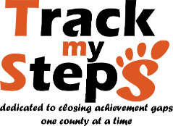

EDUCATION HELPLINE
919-295-0595
Fax
919-977-0455
admin@trackmysteps.org
www.trackmysteps.org

Date: Referred by: Email: Phone:

Parent Information
Parent’s Name:
Address:
City: | Zip | County:
Email:
Home Phone: | Cell Phone: |  | May we text you?  Yes No

Children in Home
Name | Age | DOB | Grade | School/Daycare

Parent/Student Services

What type of services are you interested in? Check all that apply.

Pre-K (birth-5yrs) Read, Set, Read (K-5th) Operation Middle (6th – 8th) Race to 100 (9th -12th)
College Prep Workshops Entrepreneur Coach EOG/EOC Resources
Scholarships Tutorials Career Prep Prayer
Attend Meeting (ex. IEP/Section 504/Conference)
Other: Other: Other: Other:

Comments:

TMS STAFF ONLY

AGI: ______ VERIFICATION TYPE: __________VERIFIED BY: ________________________ Q A CS

County: LEA CODE: Internal Audit by: Date: __________

